1. In our last lecture, we configured circuit breaker pattern.
2. Let’s run some applications.
   1. 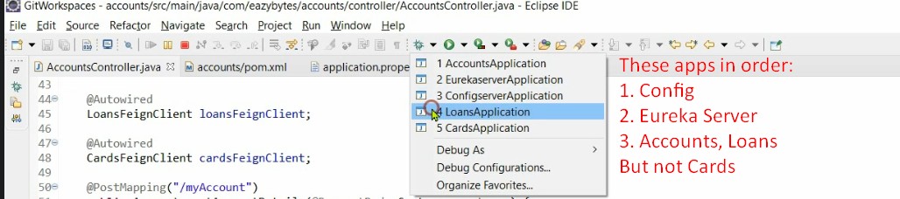
   2. We didn’t run Cards microservice to simulate the scenario where we will see how circuit breaker behaves if one service doesn’t work.
3. 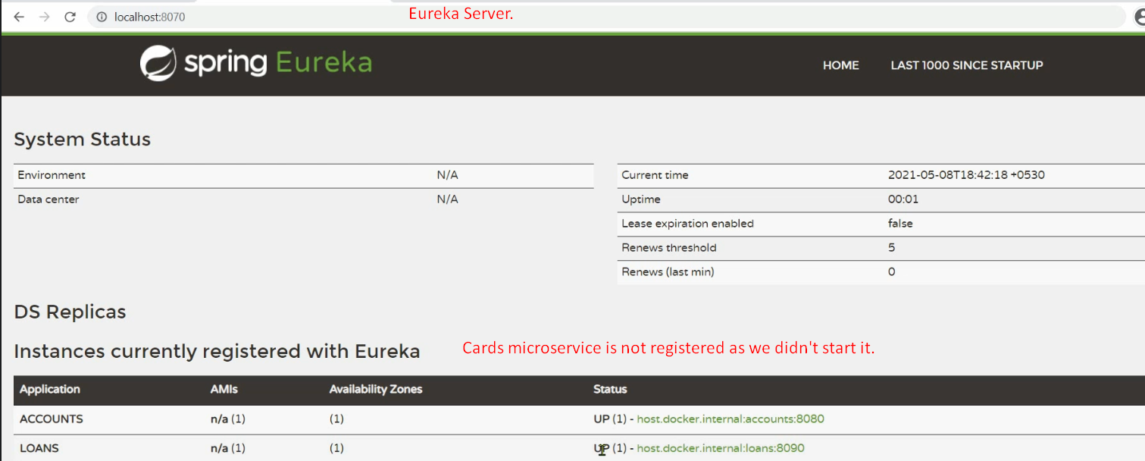
4. In last lecture, we configured a property where circuit breaker will register itself with actuator so that we can see what is happening behind the scene.
5. Let’s open the actuator endpoints.
6. 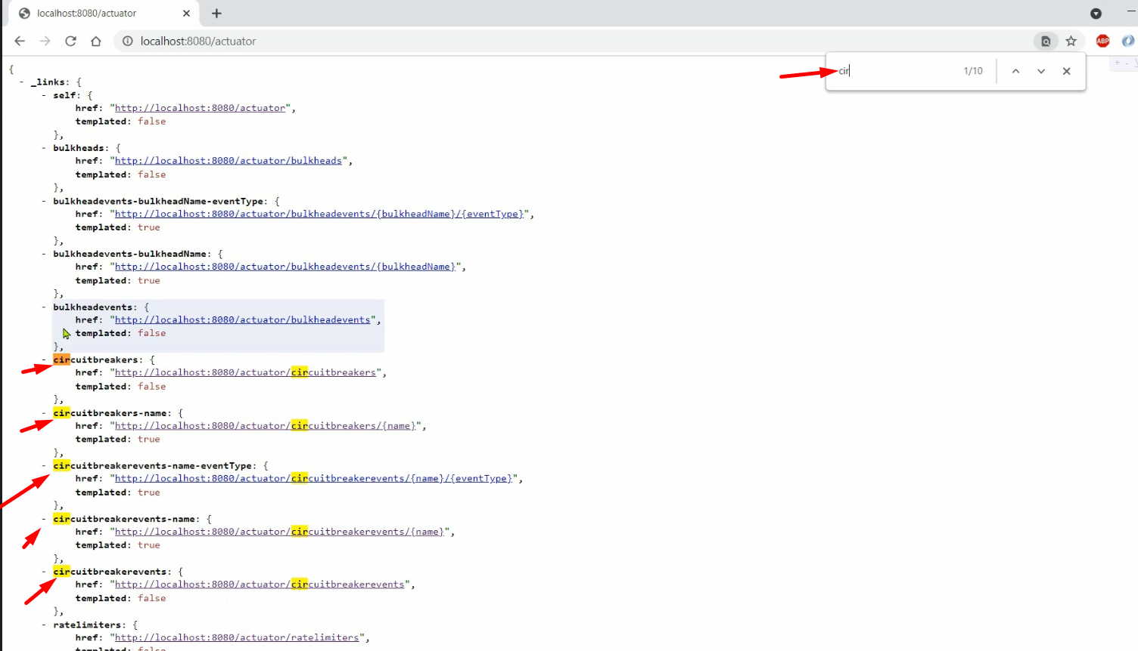
7. 
   1. 